Evaluating Information? Give it the **CRAAP** Test

The **CRAAP** Test is a bunch of questions you should ask about your sources:



***C*urrency -** *Timeliness of the information*

* When was the information published or posted?
* Has the information been revised or updated?
* Does my topic require current information, or will older sources work as well?
* Do the links work?

***R*elevance** - *Importance of the information for your needs*

* Does the information relate to your topic or answer your question?
* Who is the intended audience?
* Is the information at an appropriate level (i.e. not too elementary or advanced for your needs)?
* Have you looked at a variety of sources before determining this is one you will use?
* Would you be comfortable citing this source in your research paper?

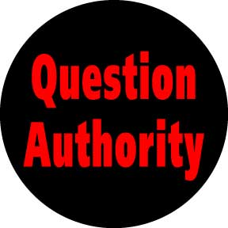***A*uthority** - *Source of the information*

* Who is the author/publisher/source/sponsor?
* What are the author's credentials or organizational affiliations?
* Is the author qualified to write on the topic?
* Is there contact information, such as a publisher or email address?
* Does the URL reveal anything about the author or source? - **.com .edu .gov .org .net**



***A*ccuracy** - *Reliability, truthfulness and correctness of the content*

* Where does the information come from?
* Is the information supported by evidence?
* Has the information been reviewed or refereed?
* Can you verify any of the information in another source or from personal knowledge?
* Does the language or tone seem unbiased and free of emotion?
* Are there spelling, grammar or typographical errors?

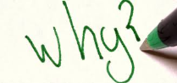***P*urpose** *- Reason the information exists*

* What is the purpose of the information? Is it to inform, teach, sell, entertain or persuade?
* Do the authors/sponsors make their intentions or purpose clear?
* Is the information fact, opinion or propaganda?
* Does the point of view appear objective and impartial?
* Are there political, ideological, cultural, religious, institutional or personal biases?