What the **CRAAP**? 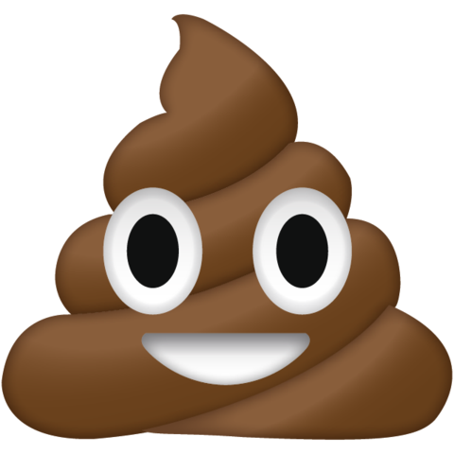 Careful NOT to step in it!

It can be difficult to know how to select a good article, book, website or

other source or determine truth from fiction, fact from opinion, fake news,

or propaganda. Is it **CRAAP**? Don’t be deceived or duped - DO give it the **CRAAP** Test: Use this apt acronym and accompanying questions to evaluate your sources, text, and information before you stake a claim or call B.S.!!

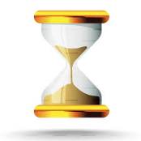

**Currency -** *Timeliness of the information*

* When was the information published or posted?
* Has the information been revised or updated?
* Does my topic require current information, or will older sources work as well?
* Do the links work?

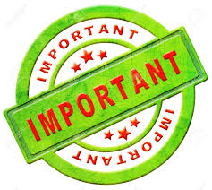**Relevance** - *Importance of the information for your needs*

* Does the information relate to your topic or answer your question?
* Who is the intended audience?
* Is the information at an appropriate level (i.e., not too elementary or advanced for your needs)?
* Have you looked at a variety of sources before determining this is one you

will use?

* Would you be comfortable citing this source in your research paper or work?

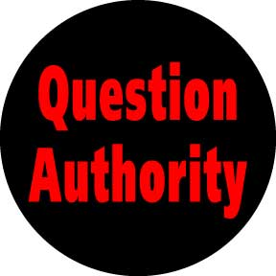**Authority** – *Source(s) of the information*

* Who is the author/publisher/source/sponsor?
* What are the author's credentials or organizational affiliations?
* Is the author qualified to write on the topic?
* Is there contact information, such as a publisher or email address?
* Does the URL reveal anything about the author or source?

- **.com .edu .gov .org .net**



**Accuracy** *- Content reliability, truthfulness and correctness*

* Where does the information come from?
* Is the information supported by evidence?
* Has the information been reviewed or refereed?
* Can you verify any of the information in another source or from personal knowledge?
* Does the language or tone seem unbiased and free of emotion?
* Are there spelling, grammar or typographical errors?

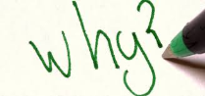

**Purpose** *- Reason the information exists*

* **Who is the target audience?**
* What is the purpose of the information? Is it to inform, teach, sell,

entertain or persuade?

* Do the authors/sponsors make their intentions or purpose clear?
* Is the information fact, opinion or propaganda?
* Does the point of view appear objective and impartial?
* Are there political, ideological, cultural, religious, institutional or

personal biases?

What the **CRAAP**?  Careful NOT to step in it!

It can be difficult to know how to select a good article, book, website or

other source or determine truth from fiction, fact from opinion, fake news,

or propaganda. Is it **CRAAP**? Don’t be deceived or duped - DO give it the **CRAAP** Test: Use this apt acronym and accompanying questions to evaluate your sources, text, and information before you stake a claim or call B.S.!!



**Currency -** *Timeliness of the information*

* When was the information published or posted?
* Has the information been revised or updated?
* Does my topic require current information, or will older sources work as well?
* Do the links work?

**Relevance** - *Importance of the information for your needs*

* Does the information relate to your topic or answer your question?
* Who is the intended audience?
* Is the information at an appropriate level (i.e., not too elementary or advanced for your needs)?
* Have you looked at a variety of sources before determining this is one you

will use?

* Would you be comfortable citing this source in your research paper or work?

**Authority** – *Source(s) of the information*

* Who is the author/publisher/source/sponsor?
* What are the author's credentials or organizational affiliations?
* Is the author qualified to write on the topic?
* Is there contact information, such as a publisher or email address?
* Does the URL reveal anything about the author or source?

- **.com .edu .gov .org .net**



**Accuracy** *- Content reliability, truthfulness and correctness*

* Where does the information come from?
* Is the information supported by evidence?
* Has the information been reviewed or refereed?
* Can you verify any of the information in another source or from personal knowledge?
* Does the language or tone seem unbiased and free of emotion?
* Are there spelling, grammar or typographical errors?



**Purpose** *- Reason the information exists*

* **Who is the target audience?**
* What is the purpose of the information? Is it to inform, teach, sell,

entertain or persuade?

* Do the authors/sponsors make their intentions or purpose clear?
* Is the information fact, opinion or propaganda?
* Does the point of view appear objective and impartial?
* Are there political, ideological, cultural, religious, institutional or

personal biases?

**Evaluating Sources in a ‘Post-Trust’ World . . .**

**. . . Ask the Right Questions!**

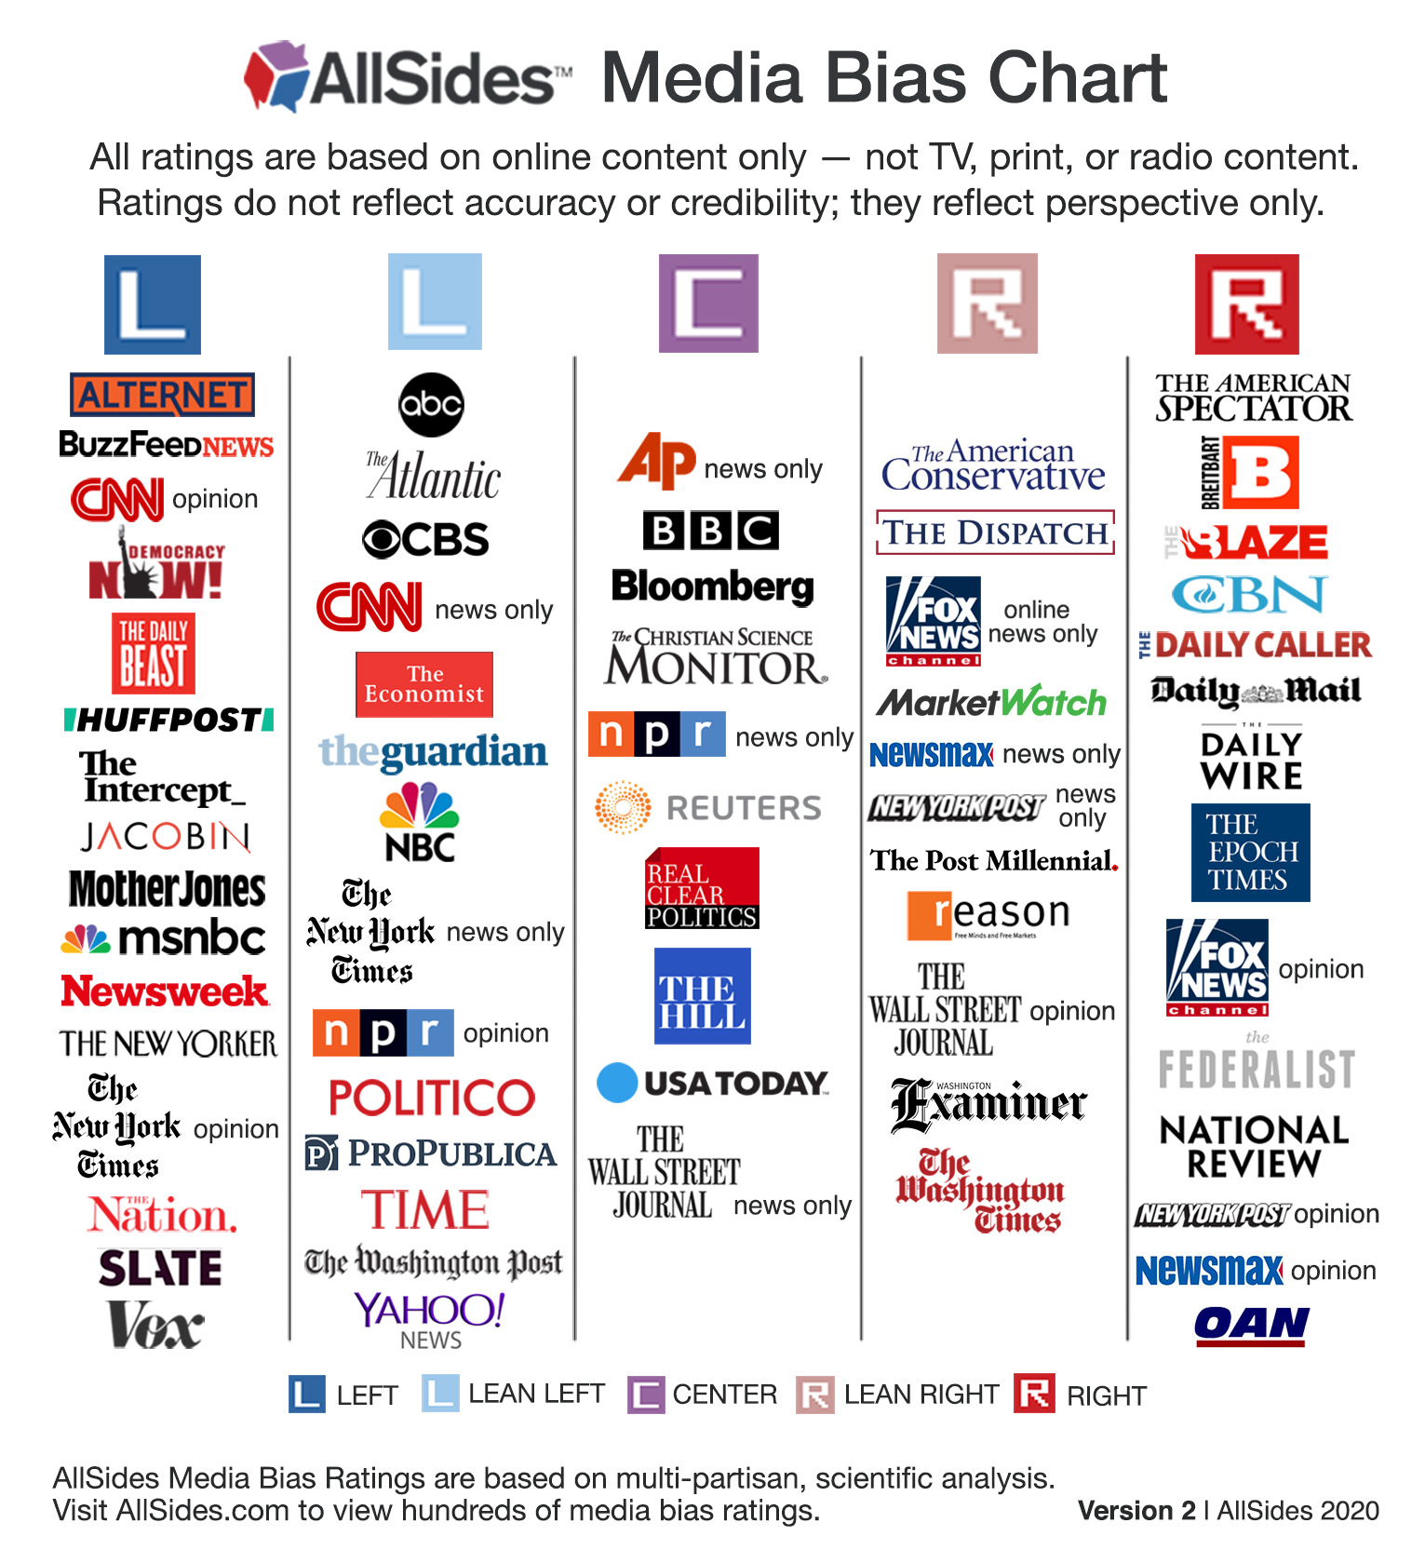

|  |  |
| --- | --- |
| **Get Used to Regularly Consulting**  **Fact-Checking Sites:** | **Conspiracy Theories? Give your source a STICKER!** |
| * **FactCheck.org** * **Snopes.com** * **Politifact.com** * **Media Bias/Fact Check.com**   **To check the authenticity of images, reverse-Google them to find their origins.** | * **Source:** **Who and what are the sources cited and why should I believe them?** * **Type:** **What type of content is this?** * **Interpretation: Is the main point of the piece proven by the evidence?** * **Completeness: What is missing?** * **Knowledge: Am I learning every day what I need?** * **Evidence: What is the evidence and how was it vetted?** * **Ramifications: What are the consequences of your findings?** |

**Evaluating Sources in a ‘Post-Trust’ World . . .**

**. . . Ask the Right Questions!**

|  |  |
| --- | --- |
| **Get Used to Regularly Consulting**  **Fact-Checking Sites:** | **Conspiracy Theories? Give your source a STICKER!** |
| * **FactCheck.org** * **Snopes.com** * **Politifact.com** * **Media Bias/Fact Check.com**   **To check the authenticity of images, reverse-Google them to find their origins.** | * **Source:** **Who and what are the sources cited and why should I believe them?** * **Type:** **What type of content is this?** * **Interpretation: Is the main point of the piece proven by the evidence?** * **Completeness: What is missing?** * **Knowledge: Am I learning every day what I need?** * **Evidence: What is the evidence and how was it vetted?** * **Ramifications: What are the consequences of your findings?** |